 SRM Institute of Science and Technology

Ramapuram campus

Department of Mathematics
18MAB101T-Calculus and linear algebra
Year/Sem: I/I Part-A Branch: Common to All
Unit -II
Functions of several variables
1. | If u and v are functionally dependent then their Jacobian value is | 1 Mark
1. | a)zero b) one c) non-zero d)greater than zero | Ans (a) | (CLO-2 / Remember)
2. | If 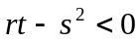 then the point is | - Mark
 | a)maximum point b) minimum point  c) saddle point d) fixed point | Ans (c) | (CLO-2 / Remember)
3. | If 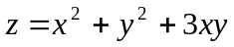 then 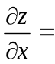 | 1 Mark
 | a)2y+3x b) 3y c) 2x+3y d) 2x | Ans (c) | (CLO-2 / Apply)
4. | If 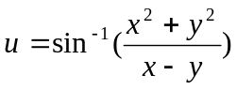 is a homogeneous function of degree | - Mark
 | a) 2 b) 3 c)1 d) 4 | Ans (c) | (CLO-2 / Apply)
5. | If f(x,y) is an implicit function then 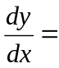 | - Mark
 | a) 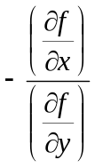 b) 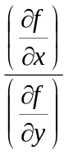 c) 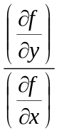 d) 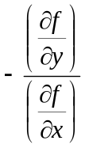 | Ans (a) | (CLO-2 / Remember)
6. | If 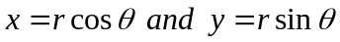 then 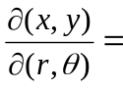 | 1 Mark
 | a) r b) r² c) 2r d) 1/r | Ans (a) | (CLO-2 / Apply)
7. | If u is a homogeneous function of degree n then 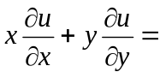 | 1 Mark
 | a) n b) nu c) u d) n²u | Ans (b) | (CLO-2 / Remember)
8. | If 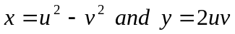 then 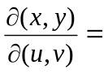 | 1 Mark
 | a) 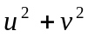 b) 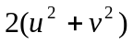 c) 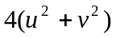 d) 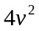 | Ans (c) | (CLO-2 / Apply)
9. | If 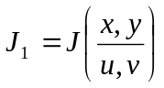 and 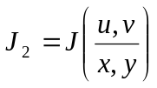then 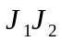 = | 1 Mark
 | a) 0 b) -1 c) 2 d) 1 | Ans (d) | (CLO-2 / Remember)
10. | The point (0.0) for 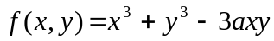 is | - Mark
 | a)maximum point b) minimum point  c) saddle point d) fixed point | Ans (c) | (CLO-2 / Apply)
11. | If 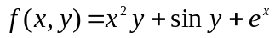 then 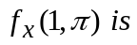 is | 1 Mark
 | a) 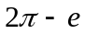 b)  c) 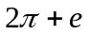 d) 0 | Ans (c) | (CLO-2 / Apply)
12. | The stationary points of 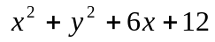 are | 1 Mark
 | a) (-3,0) b) (0,3) c) (0, -3) d) (3,0) | Ans (a) | (CLO-2 / Apply)
13. | The stationary points for are | 1 Mark
 | a) 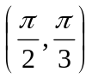 b) 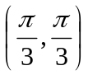 c) 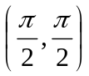 d) 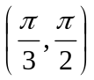 | Ans (b) | (CLO-2 /  Apply)
14. | If 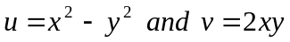 then 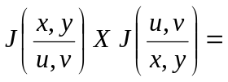 | 1 Mark
 | a) 0 b) -1 c) 2 d) 1 | Ans (d) | (CLO-2 / Apply)
15. | If 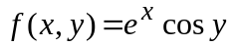 then 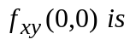 | 1 Mark
 | a) 0 b) -1 c) 2 d) 1 | Ans (a) | (CLO-2 / Apply)
16. | If 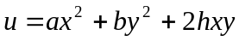 then | 1 Mark
 | a) u b) 2u c) 3u d) 4u | Ans (b) | (CLO-2 / Apply)
17. | If 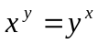, then | 1 Mark
 | a) 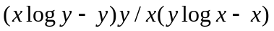  b) 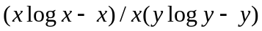  c) 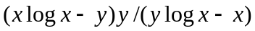  d) Does not exists | Ans (a) | (CLO-2 / Apply)
18. | If 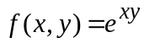 then 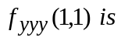 | 1 Mark
 | a) b) c) d) - | Ans (c) | (CLO-2 / Apply)
19. | If 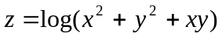 then | 1 Mark
 | a) 1 b) 2 c) 0 d) 4 | Ans (b) | (CLO-2 / Apply)
20. | If 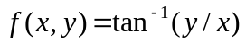 then 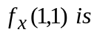 | 1 Mark
 | a) 1/2 b) -1/2 c) 2 d) 1 | Ans (b) | (CLO-2 / Apply)
21. | If V= x/y, then 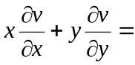 | 1 Mark
 | (a) 2V (b) 3V (c) 4V (d) 0V | Ans (d) | (CLO-2 / Apply)
22. | Saddle points are ------------ | 1 Mark
 | (a) a minimum (b) a maximum  (c) neither a minimum nor a maximum  (d) None | Ans (c) | (CLO-2 /  Remember)
23. | If u = x+y/1-xy, v= tan⁻¹x+tan⁻¹y then the functional relationship between u and v is | 1 Mark
 | a) u = tan v (b) v = tan u (c) x = tany (d) y = tan x | Ans (a) | (CLO-2 / Apply)
24. | Lagrange’s method of undetermined multipliers is to find the maximum or minimum value of a function of | 1 Mark
 | a) Two variables (b) Three or more variables  (c) One variable (d) None | Ans (b) | (CLO-2 /  Remember)
25. | The condition for a function f(x,y) to have a maximum value is that | 1 Mark
 | (a) rt-s² (b) rt-s²>0, r >0 or s> 0  (c) rt-s²>0, r<0 or s <0 (d) rt-s² = 0,r >0 | Ans (C) | (CLO-2 /  Remember)
26. | The condition for a function f(x,y) to have a minimum value is that | 1 Mark
 | (a) rt-s² (b) rt-s²>0, r >0 or s> 0  (c) rt-s²>0, r<0 or s <0 (d) rt-s² = 0,r >0 | Ans (b) | (CLO-2 /  Remember)
27. | The condition for a function f(x,y) to have neither a maximum nor a minimum value is that | 1 Mark
 | (a) rt-s² <0 (b) rt-s²>0, r >0 or s> 0  (c) rt-s²>0, r<0 or s <0 (d) rt-s² = 0,r >0 | Ans (a) | (CLO-2 /  Remember)
28. | The point (a,b) is called a stationary point if | 1 Mark
 | (a)f_{x}(a,b)=0, f_{y}(a,b)=0 (b)f_{xx}(a,b)=0 (c) f_{yy}(a,b)=0 (d)f_{xx}(a,b)=0, f_{yy}(a,b)= 0 | Ans (a) | (CLO-2 /  Remember)
29. | The minimum value of the function x²+y²+6x+12 is | 1 Mark
 | (a)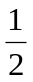 (b)2 (c)1 (d)3 | Ans (d) | (CLO-2 / Apply)
30. | The maximum value of the function x³+y³-12x-3y+20 is | 1 Mark
 | (a) 75 (b)27 (c)35 (d)38 | Ans (d) | (CLO-2 / Apply)
31. | The points at which there is no extreme value are called _________. | 1 Mark
 | - maximum points (b) minimum points (c) saddle points (d) none | Ans (C) | (CLO-2 /  Remember)
32. | If u = xe^{y}sinx v = xe^{y}cosx w =x²e^{2y} then the functional relationship is | 1 Mark
 | (a) u²+w² = v (b) v² + w² = u (c) x²+y² = u (d) u²+v² = w | Ans (d) | (CLO-2 / Apply)
33. | In PDE, a real function depends | 1 Mark
 | (a) One independent variable (b) More than one independent variable ( c ) No independent variable (d) None | Ans (b) | (CLO-2 /  Remember)
34. | If z= x²+y²+2xy then ∂z/∂x is | 1 Mark
 | (a)2x²+2y (b) 2x+2y (c) 2x-2y (d) 2y | Ans (b) | (CLO-2 / Apply)
35. | If x= rcosθ y = rsinθ then 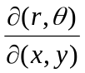 | 1 Mark
 | (a) 0 (b) 1 (c ) r (d ) 1/r | Ans (d) | (CLO-2 / Apply)
36. | If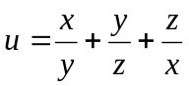, then 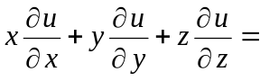_______. | 1 Mark
 | (a) 1 (b) 3 u (c) – 1 (d) 0 | Ans (d) | (CLO-2 / Apply)

